**Innovation and Entrepreneurship Development Cell**

**Title of the Project: Canopy Detection and Spraying**

*(F. No. 11/10/2015-NEB (G)/05 dated 27/07/2020)*

|  |  |  |
| --- | --- | --- |
| **Outcome in terms of Product Development** | **IPR Current Status** | **Socially and Economically Relevance** |
| * To help the farmers in bringing efficiency in the process of pesticide spraying process while minimizing health issue due to the chemicals.. * To develop the spraying mechanism in agriculture sector with less use of pesticides and fertilizers. * To detect the sapling and canopy automatically. | * In process * Enroll under SANDIP TBI in Pre-incubation Segment | * To help Farmers by easing an essential task. * To maintain fertility of the soil by giving just the right amount of pesticides. * To develop Agridrone sprayer which use less fertilizers and pesticides that savedfinancial capital. * To use the open source technology helps in increasing technology access. |

**Developed By:**

|  |  |  |  |
| --- | --- | --- | --- |
| **Young Innovators** | | **Mentor** | |
| **Student SF ID** | **Names** | **Staff SF ID** | **Names** |
| 112018275 | Abhishek Ashok Patil | 1035 | Dr. Omkar S. Vaidya |
| 112018112 | Sudhir Bhausaheb Pawar | 1097 | Dr. Gayatri M. Phade |
| 112018384 | Asit Sanjeev Bhate |

**Achivements:**

|  |
| --- |
| Participated in National Level Competitions of Prototypes Development TECHNOVA-TION 2021 organized by Dr. B R Ambedkar National Institute Of Technology (NIT), Jalandhar and Innovation Club on 6-7 March, 2021. |

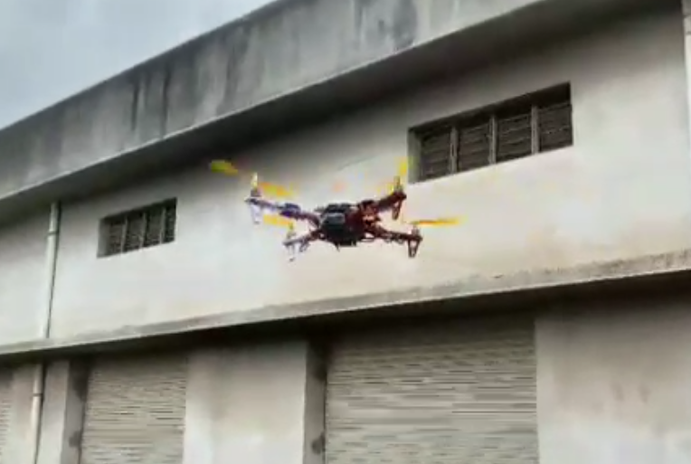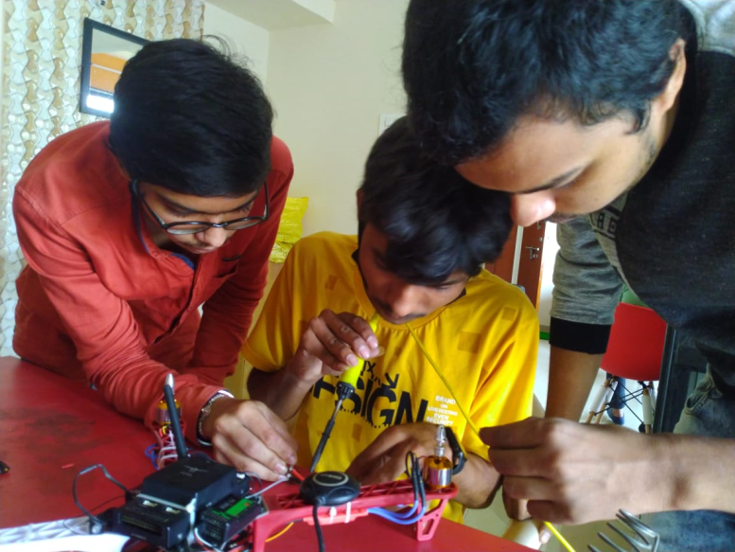

**GPS Tracking of Drones using ArduPilot**